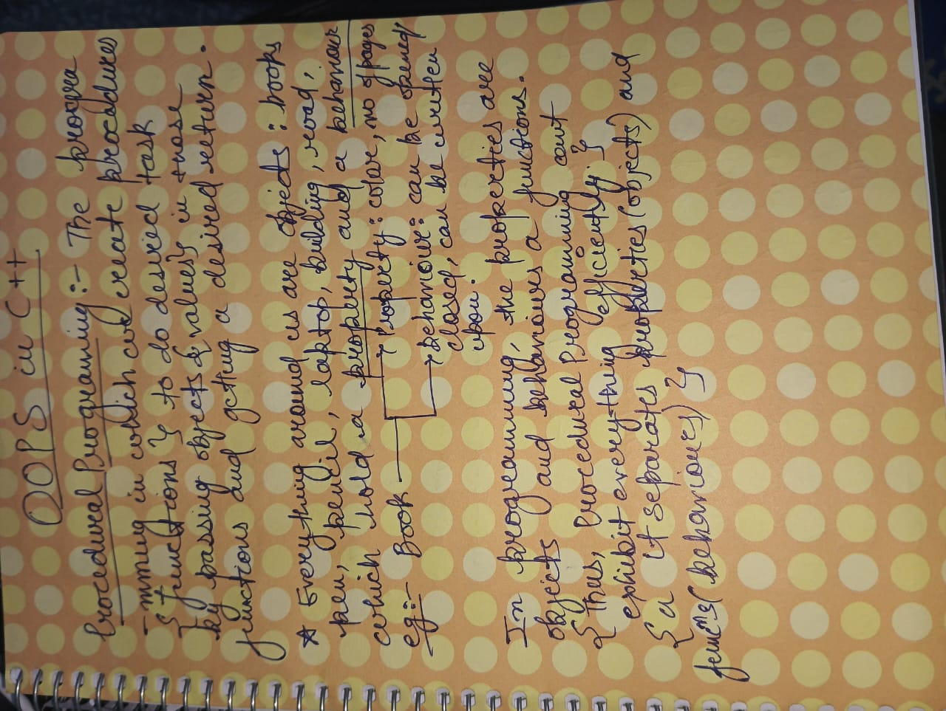

Let's break it down with a real-world example.

Imagine a Car
In the real world, a car is a single entity.
It has:
Properties (data):
- Color
- Speed
- Brand
- Fuel Level
Behaviors (functions):
- Start()
- Accelerate()
- Brake()
- Stop()
We naturally think of them together.
Car
├── Color
├── Speed
├── Fuel
├── Start()
├── Accelerate()
└── Brake()
This is exactly how OOP models reality.

How Procedural Programming Does It
Procedural programming separates the data from the functions.
struct Car
{
string color;
int speed;
int fuel;
};
Functions are written elsewhere.
void start(Car &c)
{
}

void accelerate(Car &c)
{
}

void brake(Car &c)
{
}
Notice what happened.
The Car knows nothing about starting itself.
Instead,
Car (data)

↓

External Functions

start(Car)
accelerate(Car)
brake(Car)
The data and behavior live in different places.

Why is this considered "poor representation of reality"?
Imagine a real car.
Do you think:
"Here is a car...
and somewhere else in the universe is a function that knows how to start it."
No.
You think
"The car itself knows how to start."
OOP models that intuition.

OOP Representation
class Car
{
private:
string color;
int speed;
int fuel;

public:
void start();
void accelerate();
void brake();
};
Now
Car

Data
-------
color
speed
fuel

Behavior
--------
start()
accelerate()
brake()
Everything belongs to the object.

This leads to code that looks more like this:
you.eat(apple);
This makes it clearer who the subject is (you), what behavior is being invoked (eat()), and what objects are accessories to that behavior (apple).
Because the properties and behaviors are no longer separate, objects are easier to modularize, which makes our programs easier to write and understand, and also provides a higher degree of code reusability. These objects also provide a more intuitive way to work with our data by allowing us to define how we interact with the objects, and how they interact with other objects.

A procedural vs OOP-like example
Here’s a short program written in a procedural programming style that prints the name and number of legs of an animal:
#include <iostream>
#include <string_view>

enum AnimalType
{
cat,
dog,
chicken,
};

constexpr std::string_view animalName(AnimalType type)
{
switch (type)
{
case cat: return "cat";
case dog: return "dog";
case chicken: return "chicken";
default: return "";
}
}

constexpr int numLegs(AnimalType type)
{
switch (type)
{
case cat: return 4;
case dog: return 4;
case chicken: return 2;
default: return 0;
}
}

int main()
{
constexpr AnimalType animal{ cat };
std::cout << "A " << animalName(animal) << " has " << numLegs(animal) << " legs\n";

return 0;
}
In this program, we have written functions that do allow us to do things like get the number of legs an animal has, and get the name of an animal.
While this works just fine, consider what happens when we want to update this program so that our animal is now a snake. To add a snake to our code, we’d need to modify AnimalType, numLegs(), animalName(). If this were a larger codebase, we’d also need to update any other function that uses AnimalType -- if AnimalType was used in a lot of places, that could be a lot of code that needs to get touched (and potentially broken).
Now let’s write that same program (producing the same output) using more of an OOP mindset:
#include <iostream>
#include <string_view>

struct Cat
{
std::string_view name{ "cat" };
int numLegs{ 4 };
};

struct Dog
{
std::string_view name{ "dog" };
int numLegs{ 4 };
};

struct Chicken
{
std::string_view name{ "chicken" };
int numLegs{ 2 };
};

int main()
{
constexpr Cat animal;
std::cout << "a " << animal.name << " has " << animal.numLegs << " legs\n";

return 0;
}
In this example, each animal is its own program-defined type, and that type manages everything related to that animal (which in this case, is just keeping track of the name and number of legs).
Now consider the case where we want to update our animal to a snake. All we have to do is create a Snake type and use it instead of Cat. Very little existing code needs to be changed, which means much less risk of breaking something that already works.
As presented, our Cat, Dog, and Chicken example above has a lot of repetition (as each defines the exact same set of members). In such a case, creating a common Animal struct and creating an instance for each animal might be preferable. But what if we want to add a new member to Chicken that’s not applicable to the other animals (e.g. wormsPerDay)? With a common Animal struct, all animals will get that member. With our OOP model, we can restrict that member to Chicken objects.

OOP brings other benefits to the table
In school, when you submit your programming assignments, your work is essentially done. Your professor or teacher’s assistant will run your code to see if it produces the correct result. It either does or doesn’t, and you are graded accordingly. Your code is likely discarded at that point.
On the other hand, when you submit your code into a repository that is used by other developers, or into an application that’s used by real users, it’s an entirely different ballgame. Some new OS or software release will break your code. Users will find some logic error you made. A business partner will demand some new capability. Other developers will need to extend your code without breaking it. Your code needs to be able to evolve, perhaps significantly, and it needs to be able to do so with minimal time investment, minimal headaches, and minimal breakage.
The best way to address these is by keeping your code as modular (and non-redundant) as possible. To assist with this, OOP also brings a number of other useful concepts to the table: inheritance, encapsulation, abstraction, and polymorphism.
Author’s note
Language designers have a philosophy: never use a small word where a big one will do.
Also why is the word abbreviation so long?
We’ll cover what all of these are in due time, and how they can assist in making your code less redundant, and easier to modify and extend. Once you’ve been properly familiarized with OOP and it clicks, you will likely never want to go back to pure procedural programming again.
That said, OOP doesn’t replace procedural programming -- rather, it gives you additional tools in your programming tool belt to manage complexity when needed.

